Student Name: Yuyang Gong Student Number: 49079984 Team Name: FriendZone
Week: 8
Title: Narrowing the Concept After Studio Critique

Description:
Studio feedback challenged us to explain why someone would choose FriendZone over Facebook events, Eventbrite or other meetup services. Small groups alone were not sufficiently distinctive because people can form smaller conversations inside a large event. We were advised to focus on one or two interactions, define a more specific audience and map research findings to requirements and features.
The critique also questioned whether conventional points and rewards would be meaningful. It suggested exploring a tangible interaction and making face-to-face connection the centre of the design. We responded by pausing feature expansion and researching loneliness, phone use, rewards and the difference between social isolation and the feeling of loneliness.
Visual Evidence:
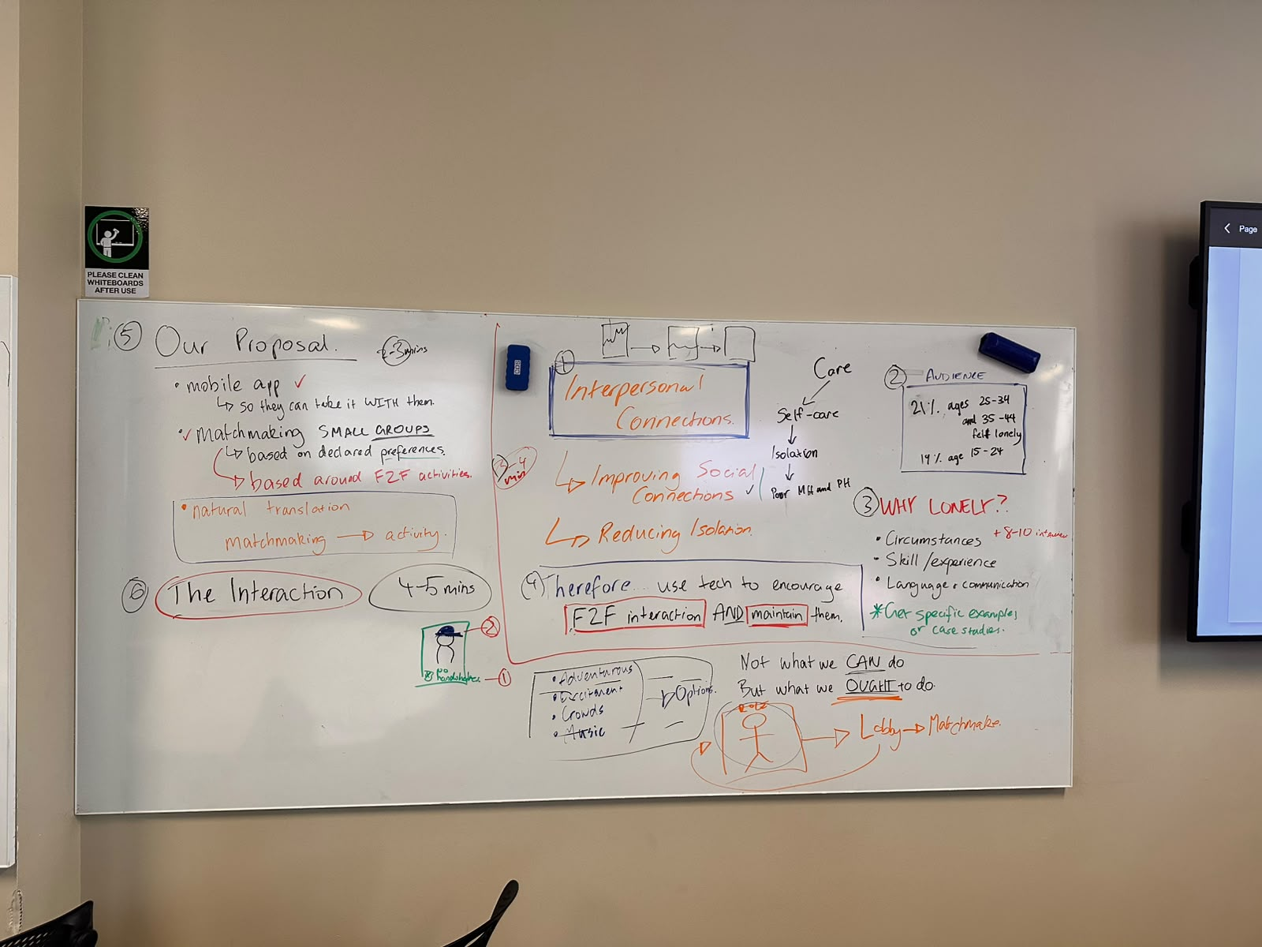
Studio board documenting the interaction journey, feedback and revised priorities.
Statement on Learning:
I learned to treat critique as a request for sharper reasoning rather than more content. A narrow concept gives us a better chance to justify decisions and test them meaningfully. The strongest direction was not a complete social network, but an interaction that helps a specific user move into a real conversation.

